Body Boggle
For those who haven't heard yet, I am going back to China this summer. I'll be teaching English teachers how to teach English with a focus on differentiation through active learning and workshop-based instruction. There are a lot of other details in there, but that's the broad scope. In preparation for the seminars, I've been thinking back over some of the games and other activities I've used in the past and Body Boggle came to mind. I cannot take credit for this, and am not sure where I originally heard the idea, but it's a fun game for practicing spelling.

I play the game using foam letter tiles that fit together to form a big mat on the floor. You could also make your own mat using a tarp, stencils, and paint (probably the cheaper option). I get the kids to lay the tiles out, putting them in order and making a large rectangle. The kids then take turns standing on A while another student draws a sort card from our pile for that week. (I use picture/word cards with my spelling words each week to enhance vocabulary. If you're interested in what I do for phonics/vocabulary instruction with my newly arrived ESL students, check out my Word Family Bonanza.) The student whose turn it is to jump then jumps from letter to letter, calling out the letters and spelling the word as he/she goes. A quick extension and additional practice is to have the student then use the word in a sentence.

I've done this activity with students of all ages and words of varying difficulty, though the younger ones tend to like it the best. The older students do enjoy it for a change, but it can get old for them very fast. Sometimes they will play it as a team, having each person stand on one letter and then spelling the word "Sparkle-style" (if you're not familiar with the spelling game Sparkle it's when the students stand in a circle and spell words by each student calling out the next letter in order).

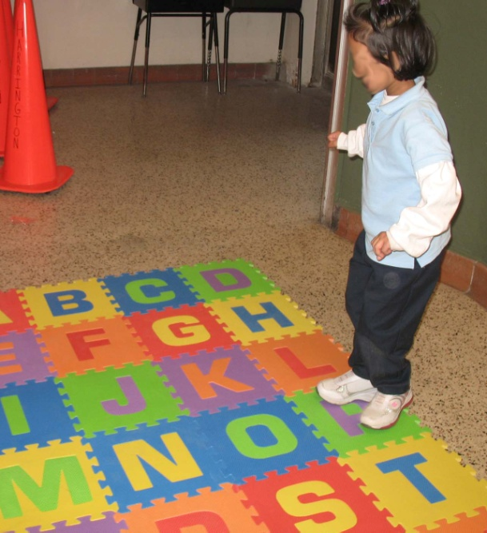
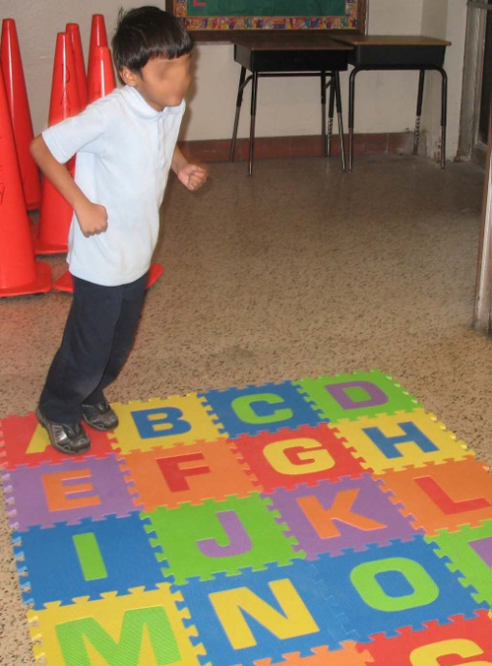
One quick tip: if you are doing this on tile floors, the mat (whatever style you use) will slip as the students jump! You'll need to find a way to keep it in place so they don't fall. I generally do play in a corner and stand on the X or Z to hold it in place when I can't find a rug or carpeted area.

